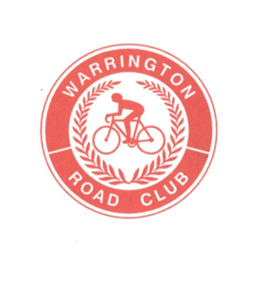
WARRINGTON ROAD CLUB

FOUNDED 1923

RESULTS SHEET

The Ron Spencer Memorial 25 Mile Time Trial

Promoted for and on behalf of Cycling Time Trials under their Rules & Regulations on Saturday 13th July 2019 on course J2/9

Event Secretary:

Alan Ottiwell, 73 Highfield Road, Lymm, Cheshire, WA13-0DT
(07814-327863) alanottiwell@hotmail.co.uk

Time Keepers:

Graham Lawrence and Martin Jackson

Thank you all for supporting this event and congratulations to the prizewinners.

A very big thank you also to all the marshals, timekeepers, headquarters personnel, and catering ladies for giving up their Saturday afternoon to support the event.

I hope to see you all again next year.

Regards

Alan

PRIZE WINNERS (** one rider one prize)

Steve Hilton, the Fastest Warrington RC rider holds the Ron Spencer Memorial Trophy for one year

